Outings and Events, February 2006
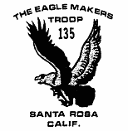
2/10-12 Snow backpack
2/18 10 mile hike in Annadel
3/17-19 Pt. Reyes backpack
4/1 Scout Camp fee due
4/28-29 Angel Island / Mt Tam biking
5/??- ?? Yolla Bolly backpack
5/?? CPR training
6/16-18 Sailing at Lake Mendocino
7/9-15 Scout Camp at Navarro
7/28-8/6 Yosemite backpack
9/16-18 Yuba River / Gold Country

* new or changed date

Missing Newsletters: Perhaps in January you got to thinking, “Hey, what happened to the December newsletter?” And perhaps this month you may have wondered the same thing about the January newsletter. In fact, you might very well have wondered what happened to the February newsletter, since that month is nearly over. Well, let’s just say the December and January newsletters never made it to press because something happened to the editor. And let’s just say that what happened involves extra-terrestrials and he has seen the inside of their spacecraft. Plus, he now has been experiencing overwhelming urges to become a counselor for the Space Exploration merit badge. Area 51 is no joke. That’s my story and I’m sticking to it.


December Outdoors: The outing in the month of December was planned for Armstrong Woods. When it was time to depart, however, only Loren Kezer showed up. The other Scouts were abducted by aliens and examined aboard their vessel, where the Scouts happened to see the newsletter editor, and were finally released unharmed a week later with no memory of the intervening events. Needless to say the trip to Armstrong Woods was cancelled.

January Outdoors: The outing in the month of January took place at Sugar Bowl, where Scouts and leaders skied and snow-boarded with great enthusiasm and alacrity. The trip was put together by none other than Jet-Eye Ski-Master Bernard Passemar, who is an expert on the slopes and is one who skis like he speaks, with a French accent. Ooh-la-la ... shoosh! There were strange, unexplained goings-on, however, that may have been due to the influence of visitors from another world. Brett Borell had his lift ticket on upside down. JJ got his snowboarding merit badge in one weekend. Eric Torre was skiing through the trees on a snowboard track and happened to glance to the side. Just as he resumed his forward gaze a tree branch came out of nowhere and caught him right across the face, jerking him off his feet and leaving a nice welt. This could be because he was skiing on a snowboard track, or it could be because he was skiing through trees and not looking where he was going. But, a question arises: what if the tree in question only looked like a tree? Can you say shape-shifter? Then there was the case of Evan Brown. He was snowboarding and did a complete 1 1/2 backflip. The judges initially awarded a 9.5, deducting only 1/2 point for landing on his back instead of his feet. After a short conference, though, the judges disqualified him. The official explanation was that it didn’t count because he didn’t do it on purpose, but we know it was really due to the influence of the short judge with no hair. The one with big eyes and three arms. Also, Robbie Passemar fell off the chair lift, apparently not once but twice. Several small children who were with him had no problem negotiating the lift, sources said. When questioned, he responded, “It was not my fault.” We wonder. In his first year off the bunny slope, Justin chose an intermediate run marked with a blue square. It was a terrain park, where he skied over a drop-off, hit powder, flipped, and hit his head on a bush. The skis were 5 feet away. It was not felt that this incident was a skill issue. Observers noted that the bush was not present when he started the run. Finally, Jarrod Mullan had a huge headache. A strange little man suggested he fashion a hat from aluminum foil and wear it at all times “for protection against them reading your thoughts.” Wisely he instead called his mother and was advised to purchase some over-the-counter medicine, which he did. Miraculously, the headache went away.

Halloween: As previously announced, there was no regular meeting on Monday October 31st. An irregular meeting was planned in which the Scouts were to be orderly and well behaved for the entire time but for some reason the Scouts declined to attend . Thus the objective of having no regular meeting was met. And there was much rejoicing.

James’ Eagle Project: James Ryall is closing in on achieving the rank of Eagle. He recently completed Citizenship in the Community and Personal Management merit badges and is working on Emergency Prep, Hiking, and Family Life. His Eagle project will be coming up soon. Scouts are encouraged to ask James what days they should set aside for working on his Eagle Project. The Troop Committee recommends that each Scout do this every week until they get an answer.

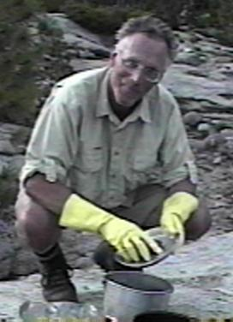
November Mystery Scout: Our Mystery Scout for the month of November was correctly identified by too many people to mention by name. That is what we get for using a famous person. Yes, that’s right, the Mystery Scout was none other than Bob Owen, star of the well-known Cleaning With Bob video series. The image at left is a still from Episode 1, where the ever-smiling Bob explains the pitfalls of using too much soap. Bob received a People’s Choice Golden Marmot award for “Best Good Sport in an Outdoor Video Series” after this episode was aired. He was the first Canadian ever to do so.

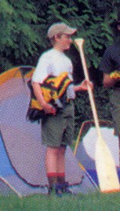
Mystery Scouts of January and February: Our mystery contest for the month of January involves a Scout. That is all the newsletter staff knows about him. Evidently he enjoys water sports and can carry items in both hands at the same time. He is in the habit of wearing shoes or boots and sometimes a hat with a bill. Neither is he afraid to bring an oar into the forest. His identity will be revealed next month by the person who submitted the photo.

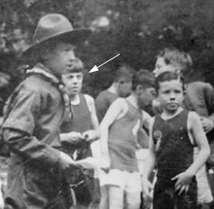
Our Mystery Scout for the month of February is related to the boy pictured at a Boy Scout foot race in 1917. The boy in the photo is the great-grandfather of one of the troop members, whose father and grandfather were also Boy Scouts. That makes him a fourth generation Scout. Can you guess who?

How to recognize different types of tree from quite a long way away: Our Scouts in December participated in a Christmas tree pickup that was extremely well organized by the dynamic duo of John Wright and Dan Brown. The Scouts were successful in recognizing the difference between Christmas trees and other types and the event raised $1582 for the troop. There was a bit of strangeness, though. In one case a box of See’s Candy was given to the vehicle in which James Ryall was riding. When the box was passed to the Scouts in another vehicle, however, there was only one piece of candy inside, the others having disappeared. The mystery remains unsolved to this day. The truck driven by JJ’s dad, Jeff Shefer, managed to pick up its entire load of 16 trees in a single run, defying the laws of three dimensional space. This was the same vehicle that received the candy box. Coincidence? We think not. Then there was the case of the truck driven by Mr. Lake, who was accompanied by Julio, Eric, and Spencer. On two separate occasions one of their trees fell out of the truck. One time it was on a freeway onramp. The tree was similar in appearance to the one that clothes-lined Eric Torre on the ski trip. A tractor beam was suspected to be involved.

And now, No. 1 The Larch.

HM GOVERNMENT, PUBLIC SERVICE FILM NO. 42 PARA 6. "HOW NOT TO BE SEEN"

In this film we hope to show how not to be seen. This is Mr. E.R. Bradshaw of Napier Court, Black Lion Road London SE5. He can not be seen. Now I am going to ask him to stand up. Mr. Bradshaw will you stand up please

(In the distance Mr Bradshaw stands up. There is a loud gunshot as Mr Bradshaw is shot in the stomach. He crumples to the ground )

This demonstrates the value of not being seen.

Cell Phones: An Alien Invention? During a recent meeting Justin Lake was attempting to describe his experience as a judge at a Cub Scout event. During the talk his cell phone kept going off, but it did not ring or play music like most phones with which we are familiar. It spoke to him. We need not point out the significance of this in light of the other happenings chronicled in this missive.

News Flash: Evan Brown got a haircut. It’s true, this was verified by numerous witnesses. Did he visit a barber or did it happen aboard a flying saucer? Don’t laugh, you should see what they do to cows.

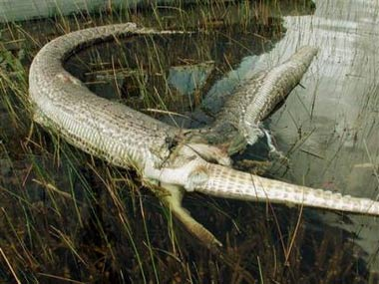
Wildlife News Correction: In our last newsletter we reported that the image below was a Burmese python that had burst after attempting to ingest an American alligator whole. We now know it is, in fact, not two creatures but a single individual and not of this planet. Yes, they are all around us.

Scout Camp 2006: Yes, indeed, it’s at Navarro, it’s July 9-15 and the cost will be $245. Or less than $245. Another possibility is it could be more than $245, but sources indicate that this is highly unlikely, and whatever is unlikely is differently because if two things are unlike they are different. In fact, the cost might be $15 less. Or it might not.

Scout Camp Update: Whether the cost is $245 or not, a $100 non-refundable deposit is due by April 1st. Lou especially wants that you should note the non-refundable part. Lou “recommends” that you not neglect to make your payment. This is not to say you are in any danger, but you know ... things happen.

Scout History From the Files of Ormond: Question: When was the “Every Scout A Swimmer” program launched? Answer: 1924.

Genius Time: Several Scouts from Troop 135 were asked to judge a contest for some of the local Cub Scouts from Pack 127. The Cubs were given a “Genius Kit” bag containing various random articles from which they were to construct an object of their own choosing. Justin, Matt, Robbie, JJ, and Ryder observed that the Tiger Cub projects were easy to judge because they all got medals. The Bear and Wolf Cubs were the hardest. Catapults and robots were a popular choice for construction, apparently.

Closet Madness: At a recent Scout meeting Brett, Julio, Evan, Justin, and Eric were observed entering the walk-in closet and closing the door. Shouts and crashing noises were heard. When an adult leader opened the door the Scouts emerged quietly from the dark interior. When asked, “What were you doing in there or are you just really good friends?” they replied that they were working on total darkness organizational skills for the Housekeeping merit badge. By the sound of it they all have a high degree of interest in total darkness management skills.

Popcorn Results: The final tally for the popcorn sales event spearheaded by Patty Passemar is $1559 sold with $530 going to the troop. Congrats to all who participated.

Intellectual Property: Our slogan list is growing despite a rather low participation level by the troop at large (zero). Remember, it is essential that we have a slogan because these are the things that add value in the New Economy. Forget things like hard work and competence, that’s right out. Here is the list so far as compiled by your faithful NewsletterTM staff.

Knots: The New Frontier
Troop 135, Originators of the Ghetto Pack and Ghetto Pants
Join Us & We’ll Give You a Knife & Let You Light Fires
100 Recipes with Top Raman: We’ll Show You How!
Sign Up Today and Add a Second Scout Free!
The Troop That Meets Every Week
Troop 135: That’s 35 More Than A Hundred
Canadians Welcome Here
Troop 135: We Go, Then We Come Back
We’ve Got Lou, Nobody Else Can Say That
Video Game Slang Spoken Here
Why Settle For Something Else When You Can Have This?
RPG: It’s Not Just For Indoors

We encourage suggestions from you all. Simply email entries to rjr@neteze.com
.

NewsletterTM:

- Insider info by J Ryall
- Additional reporting by B Cumming and M Borell
- Local color supplied by B Lake and son
- Leg Breaking and Creative Content by L Azevedo
- Editing by R Ryall.
- Email address for complaints, corrections, constructive criticism, comments: rjr@neteze.com

